AURORA ARCHITECTURE

Aurora features

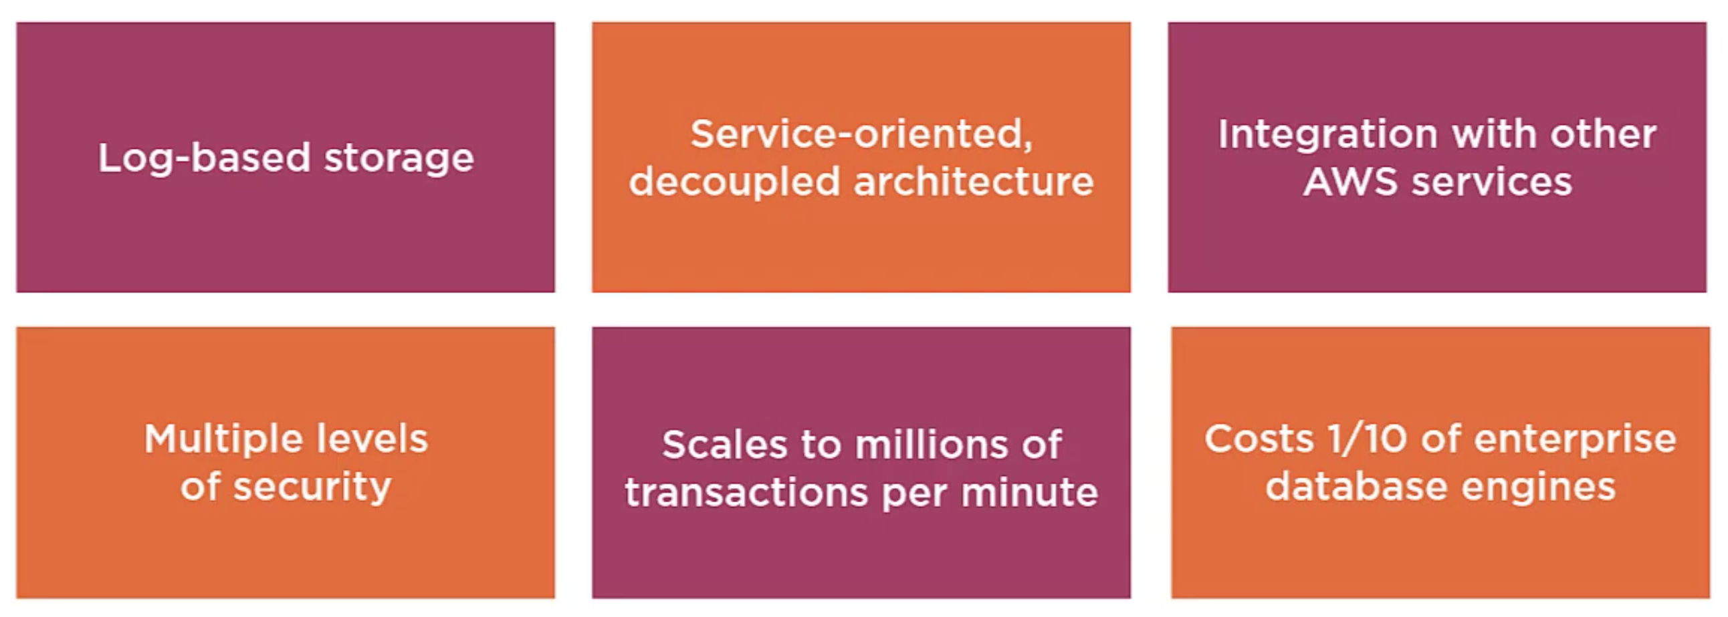

Unitl 6 copies of data, across 3 AZs, 15 replicas

Fully managed by AWS

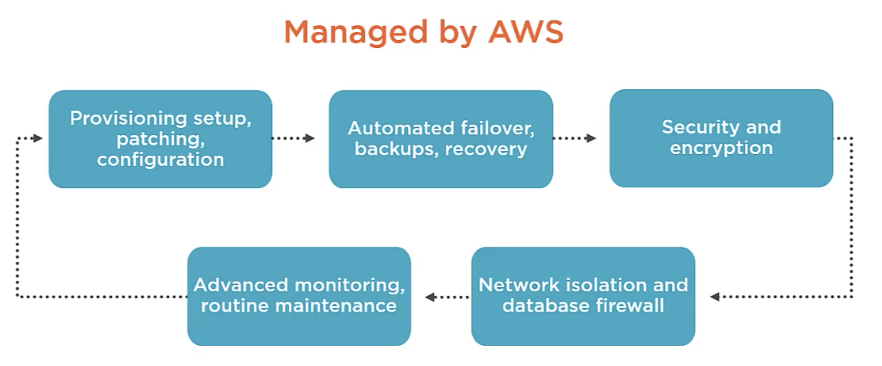

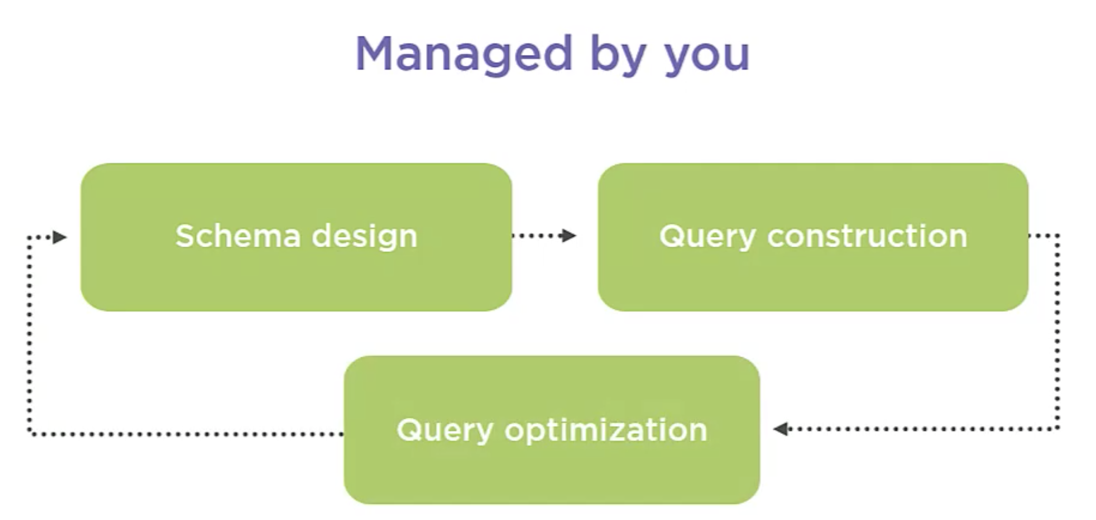

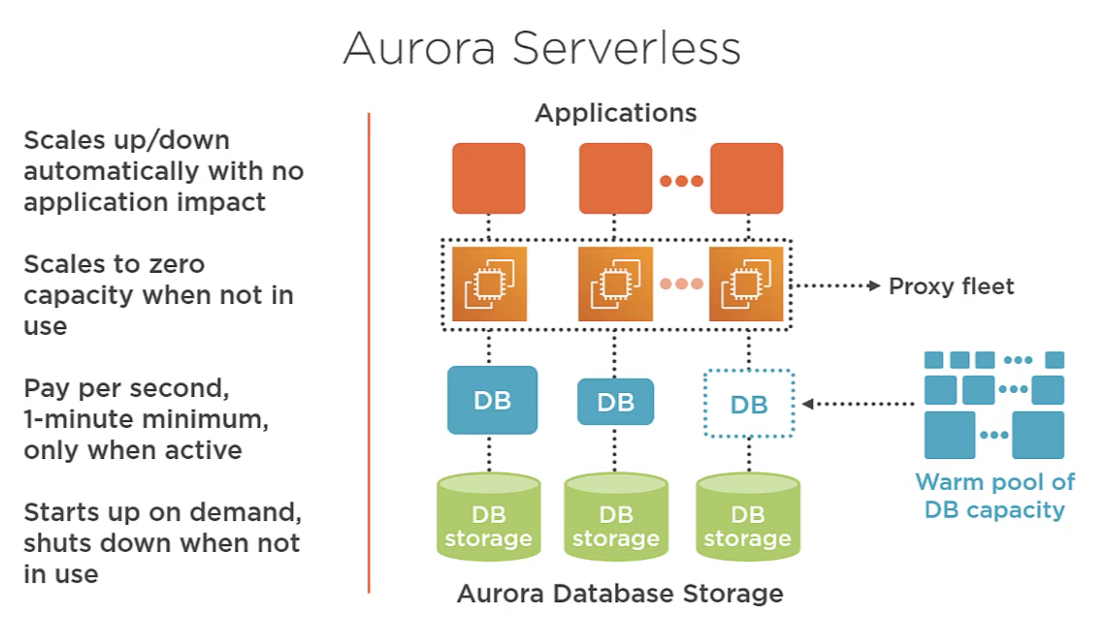

All the connections are established with the proxy fleet that allows application to pool and share connections established with the db

Beacuase of the proxy fleet the connections are continuous

Warm pool of Db capacity, allows us to have a fast scaling those are always ready to serve requests.

Storage and processing are separated, so we can scale down to zero and pay only for the storage

High level architecture

